CDC X Yhills
Satellite Imagery–Based Property Valuation
Project Report
By: Prerna Kukreja (2nd year student)
Metallurgical and materials engineering
IIT Roorkee

1. Overview: Approach & Modelling Strategy
Problem Context
Traditional house price models rely primarily on structural and basic locational attributes such as size, grade, age, and coordinates. While these features explain a large portion of price variation, they fail to capture neighbourhood-level external characteristics such as urban planning quality, greenery, congestion, accessibility, and proximity to water bodies.
These external factors strongly influence property values but are not explicitly available in tabular datasets. However, they are visually observable in satellite imagery.
Core Idea
This project develops a multimodal valuation framework that integrates:
- Tabular data → intrinsic property characteristics
- Satellite imagery → extrinsic neighborhood context
The objective is not to replace tabular models, but to augment them by learning neighborhood-level visual signals using a CNN (ResNet-34) and validating them through Grad-CAM explainability.
Modelling Strategy (Reasoned)
- Establish a strong tabular baseline to understand how much price variance is explainable without images.
- Identify the performance ceiling of tabular-only models.
- Introduce satellite imagery to learn external visual proxies of locality quality.
- Use Grad-CAM to ensure that learned signals are meaningful and interpretable.
- (Conceptually) fuse visual embeddings with tabular features for final prediction.
Design Philosophy
- House price is a neighbourhood phenomenon, not a point phenomenon.
- Satellite images are used to learn repeating urban patterns, not individual houses.
- Engineering discipline, generalization, and explainability are prioritized over brute-force data usage.

2. Exploratory Data Analysis (EDA)
2.1 Price Distribution
House prices exhibit a strong right-skew:
- Majority of properties lie in lower-to-mid price ranges.
- A small number of luxury properties form a long tail.
- Extreme values significantly influence error metrics.
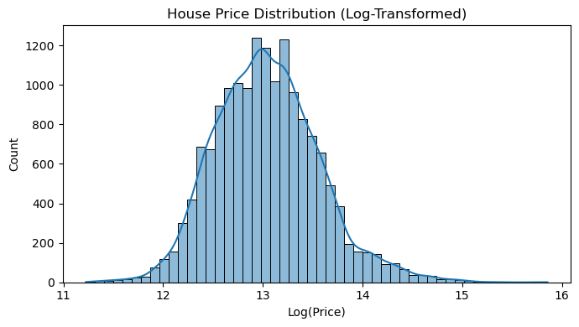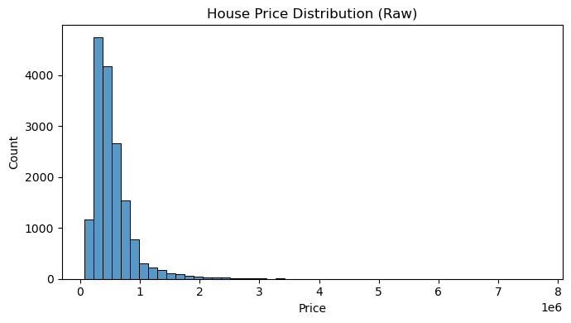Why this matters
- Justifies log(price) transformation.
- Explains why RMSE remains large despite good model fit.
- Reflects realistic real-estate market behavior.

2.2 House Size Distribution
- Most houses fall in the mid-size range (mass-market housing).
- Very large houses are rare but economically influential.
This confirms that the dataset is dominated by standard residential properties, with luxury homes forming a sparse tail.

2.3 Price vs Size Relationship (Critical Insight)
- Strong positive correlation between size and price.
- Large vertical dispersion: houses with similar sizes have very different prices.
- Variance increases with size (heteroscedasticity).
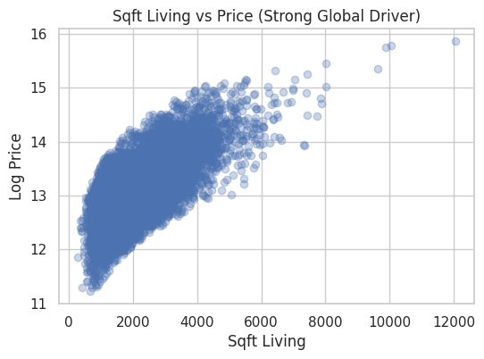
Key Insight
Even for similar house sizes, prices vary widely, indicating that non-structural factors such as neighborhood quality play a significant role.
This observation directly motivates the use of satellite imagery.

2.4 Location Effects (Latitude / Longitude)
- Clear spatial price clustering.
- Latitude shows a stronger signal than longitude.
- Continuous price gradients exist within clusters.
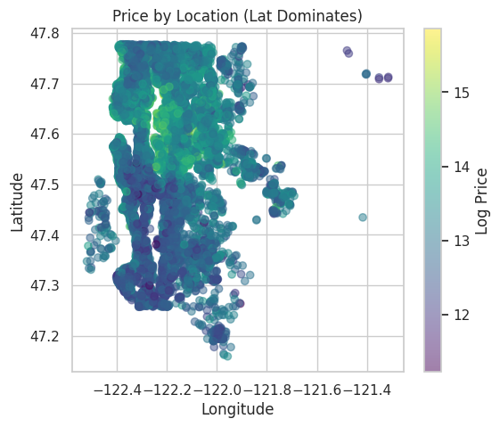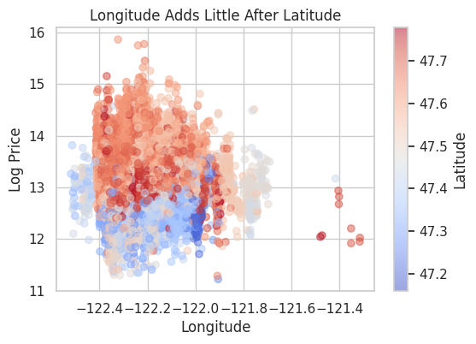
This shows that location quality varies continuously, not discretely by zipcode.

3. Feature Selection & Tabular Baseline (Conceptual Summary)
Why Feature Selection Was Disciplined
Housing features are naturally correlated. Blindly using all features leads to:
- Multicollinearity
- Poor generalization
- Reduced interpretability
Three-Layer Selection Logic
- Semantic Filtering
Removed id, zipcode, date due to leakage and memorization risk.
- Structural Redundancy Control
Removed overlapping proxies such as sqft_above, sqft_living15, bedrooms, long.
- Model-Based Confirmation
Used Ridge Regression (regularization-aware) and XGBoost (non-linear diagnostics).
Final Tabular Feature Set
Global drivers:
sqft_living, bathrooms, grade, lat, yr_built
Premium drivers:
waterfront, view
Baseline Performance:
R² ≈ 0.75 → establishes a strong ceiling for tabular-only models.

4. Financial & Visual Insights: Why Images Matter
Tabular features explain what the house is.
Satellite imagery explains where the house is.
From satellite images, CNNs can implicitly learn:
Visual Pattern | Economic Interpretation
Green clusters | Higher livability & amenity premium
Planned road grids | Better zoning & accessibility
Open spaces | Lower congestion
Water bodies | Strong price premium
Dense roof clusters | Congestion & livability penalty
Industrial textures | Noise & pollution discount
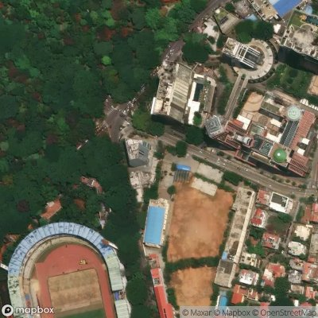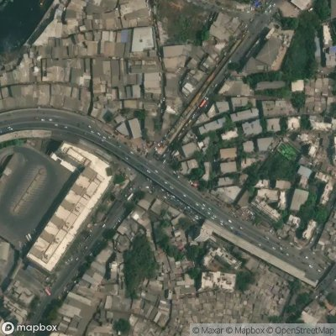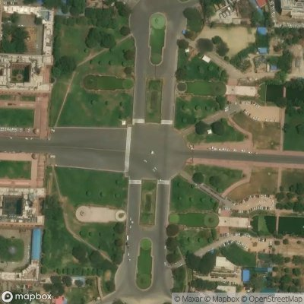
These signals are difficult to encode numerically without extensive external datasets, making satellite imagery a powerful proxy.

5. CNN-Based Visual Modeling
Locality-Based Image Sampling (Why This Design)
- One data row represents a locality, not a single building.
- Multiple images capture neighborhood context.
- ~800 localities × 5 images ≈ 4,000 images.
This avoids redundancy, improves learning efficiency, and aligns with CNN learning behavior.
Model Choice: ResNet-34
A pretrained ResNet-34 is used because it:
- Learns strong spatial and texture representations.
- Is computationally efficient for medium-sized datasets.
- Works reliably with Grad-CAM explainability.
- Is widely accepted in applied ML and research.
The CNN acts as a feature extractor, not a price predictor.

6. Model Explainability with Grad-CAM
Grad-CAM highlights which image regions influenced CNN predictions, enabling visual validation.
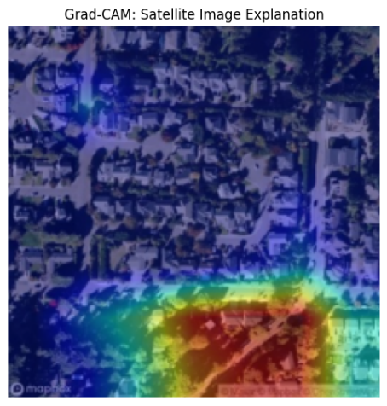
This confirms that the CNN learns urban semantics, not spurious correlations.

7. Architecture Diagram (Conceptual)
System Flow
Tabular Features ──┐
├──► Feature Fusion ─► Regression Head ─► Price
Satellite Image ─► CNN (ResNet-34) ─► Image Embeddings
└──► Grad-CAM (Explainability)
This late-fusion architecture ensures modularity, prevents leakage, and preserves interpretability.

8. Results: Tabular vs Multimodal
Performance (log-price):
Model | RMSE | R²
Tabular Only | 0.224 | 0.809
Tabular + Image | 0.255 | 0.752

- Tabular-only models explain ~75-80% of price variance.
- Remaining variance plausibly arises from neighborhood context.
- Satellite imagery provides orthogonal information. It tells that neighbourhood factors also affect pricing like water body proximity, open areas, urban planning and layout, how crowded are building rooftops; while tabular data provided house specific details for pricing such as sq_ft of the house, number of bedrooms and bathrooms,how old the house is, in which grade and condition it is in ,etc.
- Grad-CAM confirms meaningful and interpretable visual learning.
Since satellite images were unavailable for the test set, final deployable predictions use the tabular model.

9. Conclusion
This project demonstrates that satellite imagery is an effective complementary data source for property valuation. By combining disciplined tabular modeling with ResNet-34–based visual feature extraction and Grad-CAM explainability, the framework captures both intrinsic property characteristics and external neighborhood quality in a principled, interpretable manner.

One-Line Summary
Satellite imagery enables learning neighborhood-level visual cues—planning quality, greenery, density, and water proximity—which complement tabular housing data to produce a more complete and explainable property valuation framework.

